# Appendix 4 Student Reflections

We’ve had student innovators helping lead projects ([Drupal UAL](http://process.arts.ac.uk/content/drupal-ual-project-update)). Students and staff involved in the pilot development of workshops including [Video presentation skills](http://process.arts.ac.uk/category/project-groups/presentation-skills) project.

We are also in the process of gathering [DIAL vox pops](http://process.arts.ac.uk/category/tags/dial-vox-pops) videos and student feedback from the DIALogue student researcher.

## Drupal UAL (student developer reflections) Michele Durante BA Hons print making year 3

**Michele Durante BA Hons print making year 3 Feedback report on DIAL and Drupal UAL (draft 06.06.13)**

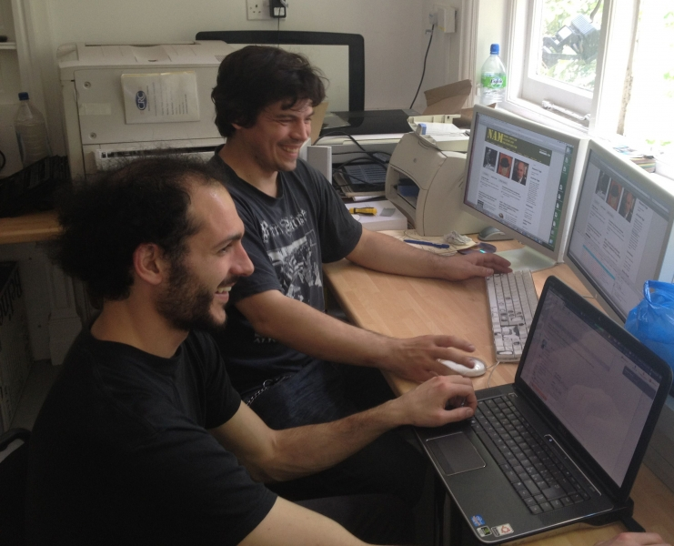

Image above, Michele (left) with UAL Drupal developer & mentor Grzesiek (right)

As an art student at Wimbledon I was quickly introduced to basic online practices by the requirements of the course, blogging and online research.

As we students progressed onto the course, more advanced skills became necessary in order to extend our practices. Personally, at that stage, I started looking into web coding as a means to gather my online research for the course, more as a tool for exploration and experimentation to find potential new ways to organize knowledge, which subsequently informed my artistic practice too. I was then introduced to online practices after the call for submission to the [ALTO competition](http://process.arts.ac.uk/content/winners-alto-comp) in November 2011. For the competition I submitted a customized Javascript code I wrote, which started my employment with DIAL while studying the 2nd year at Wimbledon and which is still ongoing today.

Through DIAL I was introduced to Process Arts and web development and design. In fact, for students it is highly beneficial to actively participate in processes of creation of online resources, the steps from blogging to a more informed way of creating and browsing those resources are not far apart. Art and design students in particular are in the position of being more accustomed to a multimedia approach to knowledge than others: I’m thinking about the visual awareness for producing potentially more engaging resources, a more comprehensive understanding of narratives just to mention a few.

Personally I found coding being a fundamental part of this process of teaching and learning. Essentially, coming from a strong background in printmaking, I see web coding as what inks and copper plates are to a printmaker: the necessary tools to achieve the final piece. In this sense, coding is not an end in itself, but could be included, probably in small parts, in every curriculum of art and design as a way to improve online communication. A Wordpress blog is an easy tool to use, but quite restrictive in terms of creativity, in terms of a more personalised approach to creating web pages. Drupal, the other major system to create websites allows more freedom, but requires a different approach.

Personally I found coding being a fundamental part of this process of teaching and learning. Essentially, coming from a strong background in printmaking, I see web coding as what inks and copper plates are to a printmaker: the necessary tools to achieve the final piece. In this sense, coding is not an end in itself, but could be included, probably in small parts, in every curriculum of art and design as a way to improve online communication. A Wordpress blog is an easy tool to use, but quite restrictive in terms of creativity, in terms of a more personalised approach to creating web pages. Drupal, the other major system to create websites allows more freedom, but requires a different approach.

Personally I found coding being a fundamental part of this process of teaching and learning. Essentially, coming from a strong background in printmaking, I see web coding as what inks and copper plates are to a printmaker: the necessary tools to achieve the final piece. In this sense, coding is not an end in itself, but could be included, probably in small parts, in every curriculum of art and design as a way to improve online communication. A Wordpress blog is an easy tool to use, but quite restrictive in terms of creativity, in terms of a more personalised approach to creating web pages. Drupal, the other major system to create websites allows more freedom, but requires a different approach.

Personally I found coding being a fundamental part of this process of teaching and learning. Essentially, coming from a strong background in printmaking, I see web coding as what inks and copper plates are to a printmaker: the necessary tools to achieve the final piece. In this sense, coding is not an end in itself, but could be included, probably in small parts, in every curriculum of art and design as a way to improve online communication. A Wordpress blog is an easy tool to use, but quite restrictive in terms of creativity, in terms of a more personalised approach to creating web pages. Drupal, the other major system to create websites allows more freedom, but requires a different approach. Drupal UAL is in fact another branch of the same vision. I was recently involved in it, it aims to create a pool of knowledge inside UAL to empower students and staff with more advanced web skills, and this would be beneficial in many ways, improving creativity and gaining more independence.

Thanks to DIAL I could also attend the Drupal Conference last year in Munich, Germany. It's been an important occasion to build new contacts in London and other countries, with other academics and professional sharing the same attitude towards websites. In a sense, what one could grasp from the Drupal community at the conference was a general attitude of openness and will to make this knowledge accessible to as many people as possible: apart from sharing specialist knowledge with who's working in the same field, some sessions focused on open access to university knowledge and academic research.