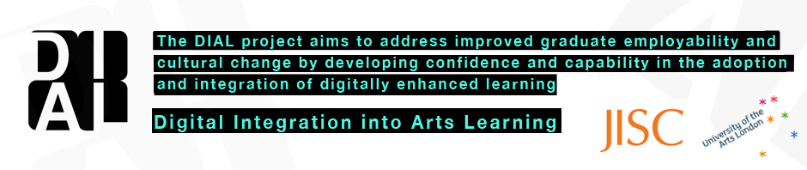

DIAL project update: Project manager Chris Follows, Academic Leaders' Forum 29th June
Project | The DIAL project (Digital Integration into Arts Learning)
Programme  Funding  Dates | Two year JISC funded digital literacies (DL) programme  100k plus matched funding (duration: <24> months)  Project start date: Nov 2011, (Programme July 11 - 4 months behind schedule) Project completion date:) Nov 2013 (Completion) July 2013 (final report due)
Websites | DIAL blog http://dial.myblog.arts.ac.uk/  process.arts http://process.arts.ac.uk/
Project Plan | http://dial.myblog.arts.ac.uk/project-plan/
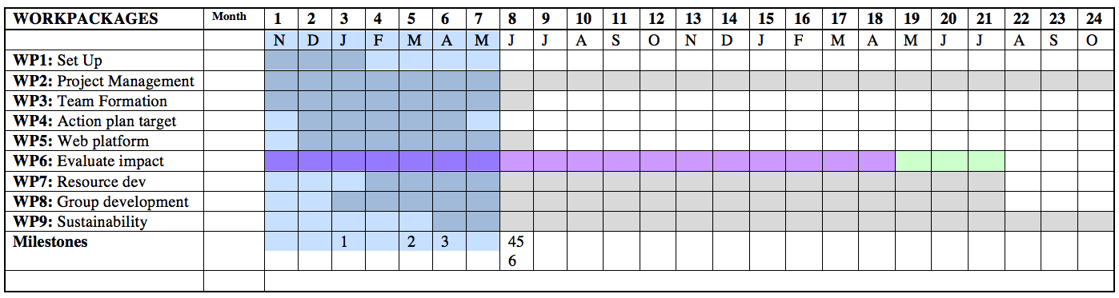
Milestones: M1 setup (project, team and groups) M2 (Group content spaces on process.arts) M3 (Group as projects/plans) M4 (Engage with industry/sector partner) M5 (long term integration with UAL webspace/environment) M6 (Year 1 Evaluation Report) M7 (Sustainability)
DIAL KEY Objectives http://dial.myblog.arts.ac.uk/2012/02/10/objectives/
Objectives: Institutional (Selected for discussion for this meeting) |  | - Embed DIAL networks and digital literacies developments into UAL web environment, policies and practices.  - Define, debate and test impact of new institutional terms, definitions and policies including: flexible learning, digital citizenship, digital literacy/capability and open education.
Objectives: Staff |  | - Improved flexible approaches to CPD & PPD staff development  - Support the implementation of digitally enhanced learning & practice
Objectives Students: |  | - Improved graduate employability by enhancing presentation skills and professional online identities.

What makes UAL a forward thinking university in terms of it digital capacity?

- Methods
- Policy and strategy
- Infrastructure
- Support and professional services
- Practices
- Developing capability
- Cultures and attitudes

Key lessons learned DIAL programme related: (Specific to this meeting)
- DIAL project or programme? (The DIAL project was always going to be bigger than a project and by acknowledging this and looking at DIAL as a potential UAL programme we can better build a case for developing a UAL wide digital strategy and sustainability plans to develop and maintain progressive digital practice at UAL. So DIAL will run as a programme and do its best to acknowledge as wide a spectrum of issues as possible although it cannot address everything.
- Ongoing and official baseline report being implemented by UAL across key departments (with DIAL board support) http://ualdigitalbaseline.myblog.arts.ac.uk/
- Integration and alignment of UAL fellowships in DIAL related projects
- New mode of delivery for the PGCert course & courses - http://dial.myblog.arts.ac.uk/2012/04/29/e-learning-strategy-group-meeting-elsg-011211/
- New platform to address Open and Flexible Learning practice at UAL, long term evaluation and reflection on progress (Nov 2013) - http://process.arts.ac.uk/category/project-groups/open-and-flexible-learning
- Following inclusion of IT (Philip Gourlay) on the DIAL project board and hearing our objectives the DIAL IT representative would like to address and establish a more open presence in UAL to help communicate better their activities, they would also like to pilot improved online resources and more participatory online environments for IT support.
 | DIAL objectives explored | DIAL Interim Report – Activities & Progress
1 | Baseline report. Identify gaps and best practice in the integration of digitally enhanced learning at UAL | Following the JISC baseline, the DIAL project board has agreed to support the development of an official institutional baseline report for its digital provision across all colleges and departments. http://ualdigitalbaseline.myblog.arts.ac.uk/
2 | Surveys http://dial.myblog.arts.ac.uk/category/survey/ | We’re currently running an online DIAL survey. The survey was circulated after the JISC baseline submission given our late project start. The survey was promoted to staff only and has received over 150+ responses. The responses are very detailed and have produced valuable data - http://tinyurl.com/dial-survey
3 | Embed DIAL networks and digital literacies developments into UAL web environment, policies and practices | DIAL Project Blog and identity  E-Learning Strategy Group meetings  STAFF & CAREER DEVELOPMENT FORUM See details  DIAL project board formed including deputy Rector, Dean and key staff - meeting agenda 12/03/12
4 | Develop and encourage more flexible learning opportunities and experiences for staff | STAFF & CAREER DEVELOPMENT FORUM See details  As part of the DIAL Open educational at UAL group  Content community - Open and Flexible Learning at UAL
6 | Increase the involvement of grassroots staff in leading university-wide DL development projects | See - http://dial.myblog.arts.ac.uk/dial-groups/  2012 Teaching & Professional Fellowship Awards, both projects are aligned closely with DIAL’s objectives – http://dial.myblog.arts.ac.uk/2012/04/12/teaching-professional-fellowship-awards-2012/  UAL Community of Practice (CoP) awards ( Communities of Practice funding to build networks ) – The Learning Studio – http://process.arts.ac.uk/category/project-groups/learning-studio and Drupal UAL – http://process.arts.ac.uk/category/project-groups/drupal-ual
7 | Define, debate and test impact of new institutional terms, definitions and policies including: flexible learning, digital citizenship and open education. | Evidence in project groups - http://dial.myblog.arts.ac.uk/dial-groups/  Focus & discussion group meetings - See here  Flexible Learning at UAL - initial thoughts  DIAL have held meetings and presentations with the Rector, the strategic Development SMT including the Deputy Rector the Academic Leaders Forum
8 | Introduce and explore notions of flexible learning, open education practice into staff CPD/PPD | Flexible Learning at UAL - initial thoughts  Open education group - http://dial.myblog.arts.ac.uk/category/open-education/
9 | DIAL to encourage, support and collaborate with ‘staff led’ fellowships, secondments and projects’ to mutual benefit of the staff involved and the common good. | DIAL were involved in the planning and selection process of the UAL Teaching & Professional Fellowship Awards 2012 - http://dial.myblog.arts.ac.uk/2012/04/12/teaching-professional-fellowship-awards-2012/
10 | Explore and debate relationships between digitally enhanced learning and perceived barriers to progressive practice including online identity, time and skills. | Developing your online professional identities - A cross project collaboration between project groups: How we use technology as participatory tool in teaching and promoting the creative student: http://process.arts.ac.uk/content/developing-your-online-professional-identities  - When and how should student’s set up their Professional Identity?  - What are the skill sets that employers are looking for from our students?  - What role is Web 2 technology playing in supporting them/this?  - How do lecturers who are also artist promote their own practice?  This survey has been created in Google Docs. We identified a problem across colleges of departments and courses wanting to evaluate skill level and digital use. Replication and repetition were a problem, several courses and departments are using this data and using the Survey tag field at the bottom so we can filter their data for local analysis.
11 | Carry out interventions and case studies that enquire and inform change and development in individual practice and student engagement and that have potential to initiate course level curriculum change. | In progress - http://dial.myblog.arts.ac.uk/dial-groups/
12 | Integrate DIAL initiatives and resources with the new Student Enterprise & Employability Service (SEE), bringing together the work of Creative Careers, the Enterprise Centre for the Creative Arts (ECCA), Artquest, Own-it and ArtsTemps. | Enterprise and employability in the curriculum - http://process.arts.ac.uk/category/project-groups/enterprise-and-employability-curriculum  Six students in Six colleges. The DIAL project is piloting different feedback methods (successful student led survey) - http://dial.myblog.arts.ac.uk/2012/01/24/dial-researcher-field-worker-pilot/
13 | Develop online skills to create and present professional self; including online presentation skills, personal website development and online professional identities. | See: http://process.arts.ac.uk/content/developing-your-online-professional-identities
14 | Explore UAL networked online communities within the university and the potential for national and international collaboration from courses, colleges, disciplines, industry and wider sectors. | Introduction of interest groups and open login to allow UAL and outside UAL participation and online collaboration - http://process.arts.ac.uk/content/what-are-project-groups
15 | Enhance student understanding of digitally enhanced learning within the context of flexible learning. | In progress - http://dial.myblog.arts.ac.uk/dial-groups/
16 | Develop confidence and capability to practice more flexible learning approaches | In progress - http://dial.myblog.arts.ac.uk/dial-groups/
17 | Improve perspectives, engagement and understanding of online learning resources. | In progress - http://dial.myblog.arts.ac.uk/dial-groups/

