**DIAL project: Digital Information Literacy Group**

**Analysis of discuss with Library Staff**

Library Services elected to form a digital info literacy group, with the aims of increasing confidence and capacity in Library Services staff, as well as capturing the skills that are evidently there. A starting point was awareness of 23 things programmes, and the idea that this could be a way forward to meet these aims.

We needed however to have a clearer idea about the existing levels of use of these tools in, and views on the potential effectiveness of the 23 things approach in our environment.

We set up a group forum on process arts, and posed 2 questions to get responses.

The first question (23 things?), in May 2012 introduced the idea of 23 things, and asked for feedback.

*Here is a good example of a 23 things program (well, 25 actually)*

[*http://25researchthings2011.wordpress.com/2011/01/25/welome/*](http://25researchthings2011.wordpress.com/2011/01/25/welome/)

*This particular example is for researchers. We thought this could be an approach for Library Services staff here for various reasons - its practical, so you do set things up, and learn something in a practical way, its also reflective as the people doing it use the tools they set up to reflect on and share progress, its flexible.*

*Quite a few questions though - what structure? How original? Many of these have Creative Commons licenses, and of course there is material in various places, including*[*process.arts,*](http://process.arts.ac.uk/) *so how much reinvention of the wheel?* How generic, *specific to our own environment?*

This has now been viewed 1685 times.

There was one reply in house, from a member of staff who is engaged in CPD 23, who gave a positive and detailed response.

The second question (2 or 3 things to start?) in June 2012 asked staff

1. *What tools would you like to be able to know more about and use? (i.e. you know little or nothing about them-beginner level)*
2. *What tools would you like to know MORE about and use in more ways? (i.e. you know enough to get-by, but you know these tools can do so much more- intermediate level)*
3. *What tools do you think you could help others to understand and use more effectively? (i.e you are a Zen master/black-belt/the person everyone asks about these tools- expert level)*

*Also we would like to know, in reference to specific examples:*

* *In general, what stops you from learning about a new tool? Is it time (I would love to play but I don’t want to give up sleep), is it confidence (I fear I could break the internet, or look foolish) or is it relevance (I don’t see these tools as relevant to my work)?*

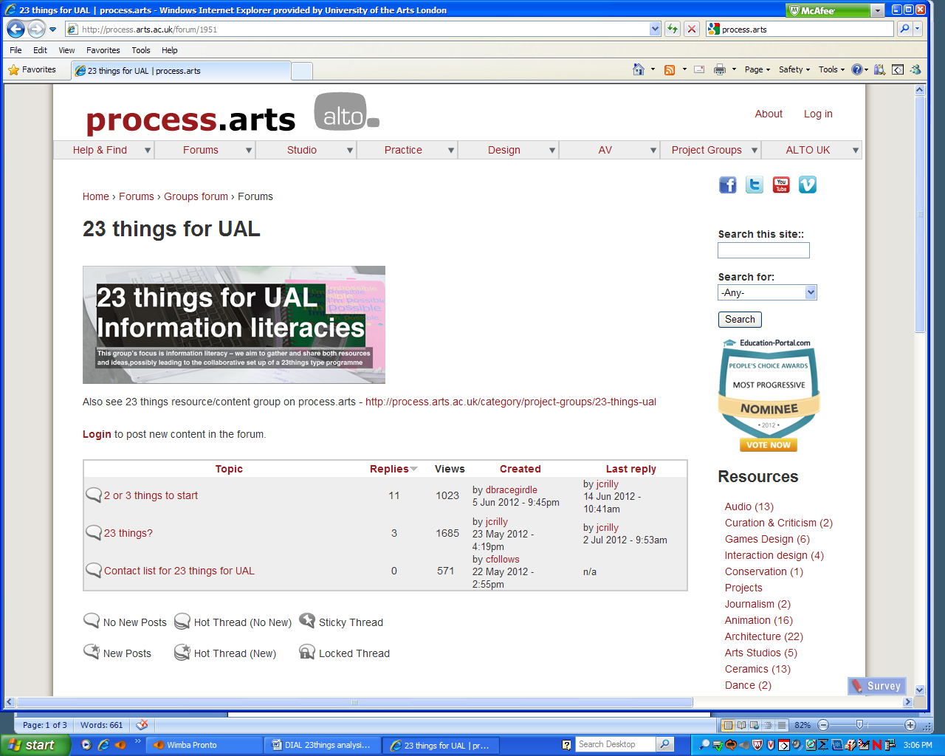

We received 11 comments, including one each from the project leaders. This has now been viewed 1023 times. Clearly this is a very small survey, and we will need further discussion...

Its interesting to note that though the number of responses was quite low, the number of views high, possibly because of the general popularity of process.arts as a forum.

An email was sent out on llr-list explaining the project and asking people to participate.

**Tools people wanted to know more about**

Specifically mentioned were:

* electronic reference/instant messaging tools,
* online enquiry service with screen sharing capacity
* tools related to copyright (Diaspora pod, BuddyPress)
* e-Library, subject scoping and saving results –

The idea of an equivalent to a driving license for skills related to online resources was suggested.

**Barriers and problems**

There were a few barriers mentioned, but time was mentioned the most, linked with a feeling of being overwhelmed by the options available. That there are so many potentially useful tools, it’s hard to find time to investigate them, and assess their usefulness.

Also mentioned were

* The need for a plan or strategy for our use of social media in Library Services.
* Lack of confidence developing professional profile.
* Our own practice in managing images as Library Staff?
* The number of initiatives in the University and keeping track of them.
* The need to make better use of the VLE, Moodle when it arrives
* The lack of encouragement from managers to use web 2 and social media in an innovative way and concern that we are lagging behind, and are fearful.
* The need for a high level understanding
* Ending up with too many accounts to manage and remember
* Difficulty in developing real expertise

**What people do now**

Some staff use web 2/social media personally (blogs, Twitter) but not professionally. Some use it for both, and feel they could help other staff. Most follow blogs and tweets.

Also mentioned were

* Hootsuits
* LinkedIn
* Evernote, Astrid Tasks, Doodle and others
* Blackboard
* Lynda.com
* Prezi,
* Diigo,
* Mendeley
* Flikr