**DIAL update for SMT**

**Background**

DIAL stands for Digital Integration into Arts Learning. It’s a University wide JISC funded project, one of the projects in the JISC Developing Digital Literacies Programme.

The JISC definition of digital literacy is:

“The capabilities, aptitudes and attributes learners need to thrive in a digital economy and society.”

DIAL is a network of self identifying communities within UAL who want to “articulate their digital literacies goals and aspirations, assess their existing skills and confidence levels, and develop processes to support their development, including the generation of resources...” (Chris Follows, DIAL project Manager)

From the outset of the DIAL project it seemed a good opportunity for Library Services to engage with other University staff in discussions around digital literacy, and to look at means of developing our own skills.

The project was initiated by David Bracegirdle and Jess Crilly, and more recently Karen Ellis Rees.

**Things Unlimited**

We initially looked at programmes like *23things*, online programmes introducing web 2 tools, but after discussion with library staff developed the idea of “things unlimited”, a series of resources on topics of interest to our Library staff, rather than a programme delivering topics and resources in a specific order.

To gauge the views of Library Services staff, we initially held a discussion on process.arts. Uptake was quite low; nevertheless some barriers to the uptake of learning about web 2 became clear. (The barriers were: time to experiment and learn, the sheer number of resources available, and lack of clarity about their importance within our roles.) We also employed an ArtsTemp student at the Library Services Conference in September to ask staff about what resources and tools they were already confident using, and what they wanted to know more about.

The results were:

Heard of, would like to know more:

* Presentation tools
* Using OER (Open Educational Resources)
* IPR issues

Already confident users:

* Social media
* Blogging
* Sharing documents

Priority areas for skills development:

* Web based reference management tools (e.g. Zotero)
* Using OER
* IPR issues

This process was helpful in allowing us to decide which resources to develop first.

**The prototype**

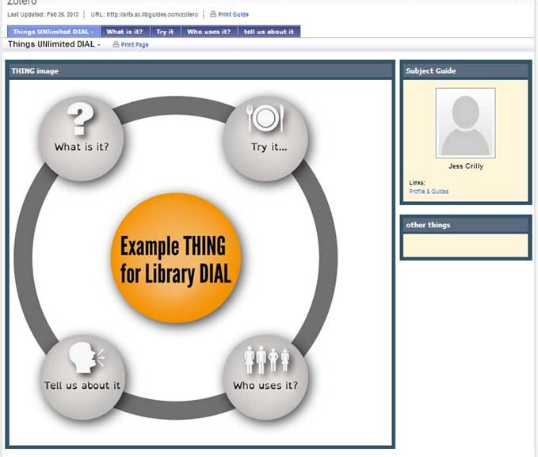

After discussing options with the DIAL project staff we decided that LibGuides was the best software for us to use, as its already available, familiar to our staff, and relatively easy to use.

For each topic, there are 4 sections:

**What is it?** This is a “from the beginning” explanation, or definition of the tool or topic.  
**Try it..**.: Some sort of practical exercise (log in, do this, try that...)  
**Who uses it**: This addresses our own use of the resource, for example, is it something delivered by Library Services staff in “info skills” sessions, or by other colleagues: examples of good practice from other Universities/libraries: how its typically used by students, researchers etc

**Tell us about it**: A survey asking for feedback.

The prototype (on web based reference management tools, focussing on Zotero, will be ready within the next week or so, and we will be asking for feedback on the format and content, before developing any further resources.

**Next steps and sustainability**

Sustainability is the real challenge to any project of this sort, which has no additional resourcing.  
One of the aims is to capture knowledge within the department, as well as work with other colleagues working in similar areas in the University, so we hope that a range of people will contribute to, own or co-own LibGuides on various topics. We are not working with a deficit skills model, but rather want to use existing knowledge and skills to create shared resources.

They will be made available as open educational resources, and some knowledge and experience will be gained through that process, for example of using creative commons licences.