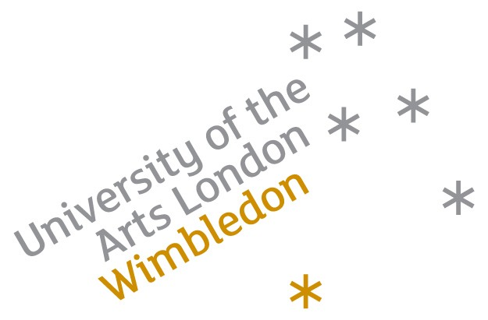

English Plus Film
During this course students will have the opportunity to look at the work of contemporary artists and directors making experimental video. The course will also include a brief history of video art.
All this will be set in the context of the practical nature of this course, and students will take part in video workshops using Mini DV cameras, phone and flip cameras. Students will be shown how to edit and enhance their videos using Mac computers with Final Cut studio Pro software. Videos can include animation sequences or found/old footage edited together. Students will be shown basic stop frame animation methods using a stills camera either out and about on location in London or in a studio with lights using animation software iStopmotion.
-Exhibition - students will author their final video work onto DVD using DVD Studio Pro and have a group critique screening and exhibition at the end of the course.
-Visit - a visit to a London film lab may be possible.

