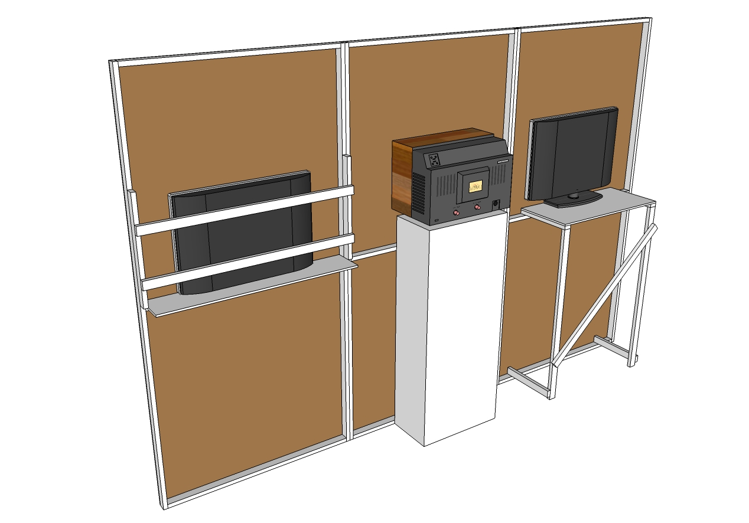
Guide to Fitting TV’s and Monitors to Theatre Flats
Remember:
All electrical equipment needs to be PAT tested before the show. You will also need to fill out a risk assessment for your work.
Here the TV has had the base removed. An MDF or timber board is screwed to the centre bar to carry the weight of the TV. The thickness of the theatre flat has been increased on the sides with extra 50 x 25mm timber and cross-braces fixed across the back of the TV to secure it. If necessary, wedges can be used between the cross-braces and the rear of the TV for a more snug fit.
Heavy TV’s and Monitors need to be mounted on a plinth or table.
This flat screen TV has been left on its' base and stood on a more complicated support. Model boxes can also be stood on shelves like this.

