Finding and using images in your teaching: class activities

Activity 1: Using Flickr to find Creative Commons licensed images

Use the Flickr Creative Commons image search to find some images of relevance to your teaching or research.

Step-by-step:
- Go to Flickr Creative Commons (http://www.flickr.com/creativecommons/) and look at the variety of Creative Commons options on the right hand bar.
- Select ‘see more’ under the ‘Attribution-NonCommercial-NoDerivs License’ option.
- Search for a subject area relevant to your studies or teaching.
- If you find an image you wish to save: Right click image and ‘Save Image As…’

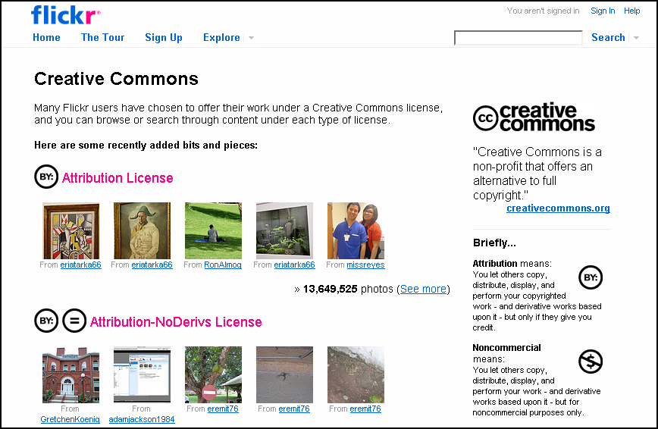

- Save an image onto your H Space ready for inserting into PowerPoint later. Make sure to note the image owner and title of the image as listed on Flickr.

Activity 2: Searching the Education Image Gallery

Search the Education Image Gallery for images useful for your teaching.

Step by Step:
- Go to The Education Image Gallery (EIG) (http://edina.ac.uk/eig/) and log on “via UK federation”. Choose LSE from the list and click Select. Use your LSE login details to log in.
- Find an image related to your research by searching in the search box.
- Click on your chosen image. Follow the ‘Tips for download images’ instructions, at the top of the page.
- Look at the Terms of Use for this collection.
  - Can you use the images on a personal website?
  - Can you use the images in a conference presentation?
Image Placeholder

Image: screenshot of Education Image Gallery website

Subscription resource: Yes

URL: http://www.edina.ac.uk/eig/

Edited: Yes

Amendments: Cropped to remove browser window. Link to terms of use highlighted with circle at bottom of screen.

Date: May 2009

Activity 3: Terms of use when searching for images on the web

- Visit the National Archives website: http://www.nationalarchives.gov.uk/
- Find the Terms of Use page at the bottom of the screen.
- Can you use images from this site in your teaching?

- Visit the Morgue File website: http://www.morguefile.com/
- Can you use images from this site in your teaching?
- Are there any restrictions on the use of the images?
Image Placeholder

Image: Screenshots of National Archives website and Morgue File website

Subscription resource: No

URL: http://www.nationalarchives.gov.uk/
http://www.morguefile.com/

Edited: Yes

Amendments: Browser removed

Date: May 2009

Activity 4: Editing your images

Insert image into PowerPoint

- In PowerPoint create a new blank slide
- Insert a Picture using Insert menu > Picture from file
- Locate the image you saved onto your H Space in Activity 1 and insert this into the slide. The image can be resized by clicking on it and using the handle in the bottom right corner.

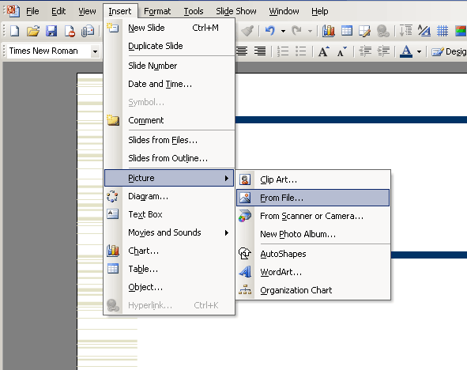

Crediting your image

1. Use the image title and name of the image owner (from Flickr) to credit your image on the slide.

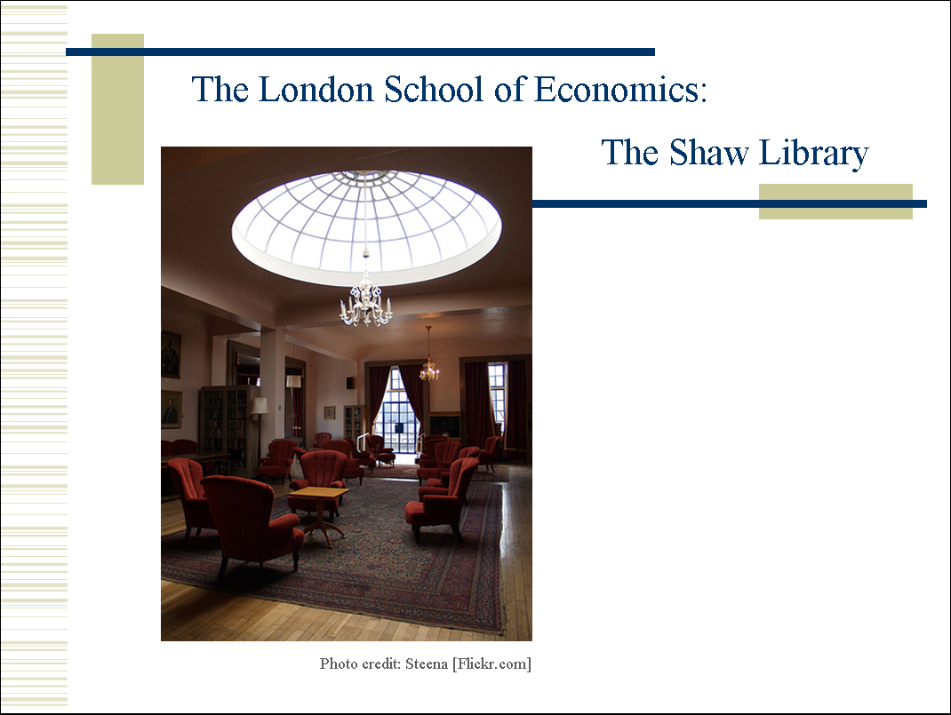

Further training opportunities
IT Training course on ‘Editing Images’ and ‘Images and Frontpage’

